Data Science
CA3 (Mini Project)

Submitted by

Asita Ganatra, 22070521003

B. Tech Computer Science and Engineering

Under the Guidance of

Dr. Piyush Chauhan



Wathoda, Nagpur
2025

This is to certify that the DS EDA report titled “Analysis and Forecasting of Credit by Scheduled Commercial Banks in India (2010-2023)” that is being submitted by Asita Ganatra, 22070521003 is in partial fulfillment of the requirements for the DS Project is a record of Bonafide work done under my guidance. The contents of this Project work, in full or in parts, have neither been taken from any other source nor have been submitted to any other Institute or University for award of any degree or diploma, and the same is certified.

Dr. Piyush Chauhan
DS Project Coordinator

The Report is satisfactory/unsatisfactory

Approved by

Prof. (Dr.) Nitin Rakesh
Director, SIT Nagpur

ABSTRACT

This project presents a comprehensive data science application for the analysis of credit by scheduled commercial banks in India from 2010 to 2023. The primary problem addressed is the need for an integrated tool to explore, analyze, and predict key banking metrics. The methodology involves developing an interactive web application using Streamlit, which integrates multiple machine learning paradigms. This includes (a) exploratory data analysis (EDA) for trend visualization, (b) predictive modeling using Linear Regression and Random Forest models to forecast loan amounts and account numbers, (c) classification analysis to categorize bank groups and regions, (d) unsupervised clustering with KMeans, DBSCAN, and Agglomerative algorithms to discover hidden patterns, and (e) deep learning models, including Autoencoders for dimensionality reduction and Deep Neural Networks (DNNs) for advanced classification. Key findings indicate that Random Forest models (R^2 ~0.92) outperform Linear Regression (R^2 ~ 0.85) in prediction tasks, and the DNN classifier achieves high accuracy (~90%). The significance of this work lies in its creation of a single, powerful, and user-friendly tool for banking professionals to derive actionable insights from complex credit data.

TABLE OF CONTENTS

Chapter | Title | Page Number
 | Abstract | 3
 | Table of Contents | 4
1 | Keywords | 5
2 | Introduction | 5
3 | Literature Review / Related Work | 5
4 | Methodology / Proposed System | 6
5  5.1  5.2  5.3  5.4  5.5 | Implementation  Main Dashboard  Predictive Modeling  Classification Analysis  Clustering and Deep Learning  Challenges Faced | 7  7  8  9  9  10
6 | Results And Discussions | 11
7 | Conclusion and Future Work | 11
8 | Reference | 12

1. Keywords

Data Science, Machine Learning, Bank Credit Analysis, Predictive Modeling, Classification, Clustering, Deep Learning, Streamlit, Python

2. Introduction

• Background/Context: The Indian banking sector generates vast amounts of data on credit distribution, an essential indicator of economic health. Analyzing this data, which spans multiple regions, bank types, and population groups, is critical for financial institutions and policymakers.
• Motivation: The motivation for this study is to bridge the gap between raw banking data and actionable insights. By applying a full spectrum of data science techniques, from EDA to deep learning, we can uncover trends, build predictive models, and create a tool that makes this complex data accessible and useful.
• Problem Statement: To design and implement a comprehensive data analysis system that provides an interactive dashboard, predictive modeling, classification, and clustering for Indian commercial bank credit data from 2010-2023.
• Objectives of the Project:
- Develop an interactive dashboard for banking data visualization.
- Implement predictive models for loan amount and number of accounts.
- Create classification systems to identify bank groups and regions.
- Implement clustering algorithms for customer and loan pattern discovery.
- Integrate deep learning capabilities for complex pattern recognition.
• Novelty of your work: The novelty of this project lies in its all-in-one, modular design. It's not just a single model but a complete web-based analytical suite (built with Streamlit) that allows a user to perform EDA, regression, classification, clustering, and deep learning on the same dataset through a single, intuitive interface.

3. Literature Review / Related Work
Previous research in banking and finance has extensively used empirical and statistical models to identify the key predictors of bank risk, credit quality, and profitability. These studies often differentiate between internal (bank-specific) factors and external (macroeconomic) factors.
One major area of study, exemplified by Suzdaltseva (2025), focuses on identifying the predictors of bank risk across multiple dimensions, including credit, liquidity, and systemic risk. This research uses panel data from numerous banks to find consistent drivers. Common internal predictors investigated include profitability (like Return on Assets), capital adequacy (CAR), and operational efficiency, while external predictors include macroeconomic variables like GDP growth and inflation. The general finding is that stronger internal metrics, such as higher profitability and capital, consistently reduce bank risk.
Another branch of related work analyzes credit management practices in specific regions, such as the study by Dhakal (2024) on commercial banks in Nepal. This research uses regression analysis to determine the impact of credit management variables (like Non-Performing Loan Ratio (NPL) and Loan Loss Provision (LLP)) on bank performance, often measured by Return on Equity (ROE).
Gaps with the earlier work: While these studies provide a strong foundation for using statistical models to analyze bank data, many (like Dhakal) focus on establishing regression-based relationships rather than on the forecasting capabilities of machine learning. Furthermore, these studies are specific to other regions (Europe, Nepal). This project fills a gap by applying a dedicated data science and machine learning approach to forecast commercial bank credit data specifically within the Indian context.

4. Methodology / Proposed System
The proposed system is an interactive web application built in Python using the Streamlit framework. The system is designed with a modular architecture, allowing users to navigate between different analytical tasks.
Algorithms and Formulations:
- Predictive Modeling (Regression):
  - Linear Regression: Used as a baseline model to predict log-transformed amount_outstanding and no_of_accounts.
  - Random Forest Regressor: An ensemble model used for its high accuracy and ability to capture non-linear relationships.
- Classification Analysis:
  - Logistic Regression: Used as a linear baseline for classifying bank_group and region.
  - Random Forest Classifier: An ensemble model for robust, high-accuracy classification.
- Clustering Analysis:
  - KMeans: For partitioning data into $k$ distinct clusters.
  - DBSCAN: For density-based clustering to identify noise and arbitrary shapes.
  - Agglomerative Clustering: A hierarchical approach to build a tree of clusters.
- Deep Learning:
  - Autoencoder: A neural network for unsupervised dimensionality reduction.
  - Deep Neural Network (DNN): A multi-layer perceptron for high-performance classification.
Tools, Libraries, and Frameworks:
- Python: Core programming language.
- Streamlit: For building the interactive web application.
- Pandas & NumPy: For data loading and manipulation.
- Scikit-learn (sklearn): For all machine learning models (Linear/Logistic Regression, Random Forest, Clustering) and preprocessing.
- TensorFlow/Keras: For implementing the Autoencoder and DNN.
- Plotly & Matplotlib: For data visualizations.
- Joblib: For saving and loading trained machine learning models.

5. Implementation
The system is implemented as a multi-page Streamlit application, with the main script app.py acting as the router.

5.1 Main Dashboard
A dashboard provides a high-level overview. It features:
• Key Performance Indicators (KPIs): Total Amount Outstanding, Total Number of Accounts, and Total Districts for the filtered data.
• Interactive Filters: Sidebar controls to filter the data by Year Range, Region(s), and Bank Group(s).
• Visualizations: Bar charts showing "Amount Outstanding by Bank Group" and "Top 10 States by Amount Outstanding."
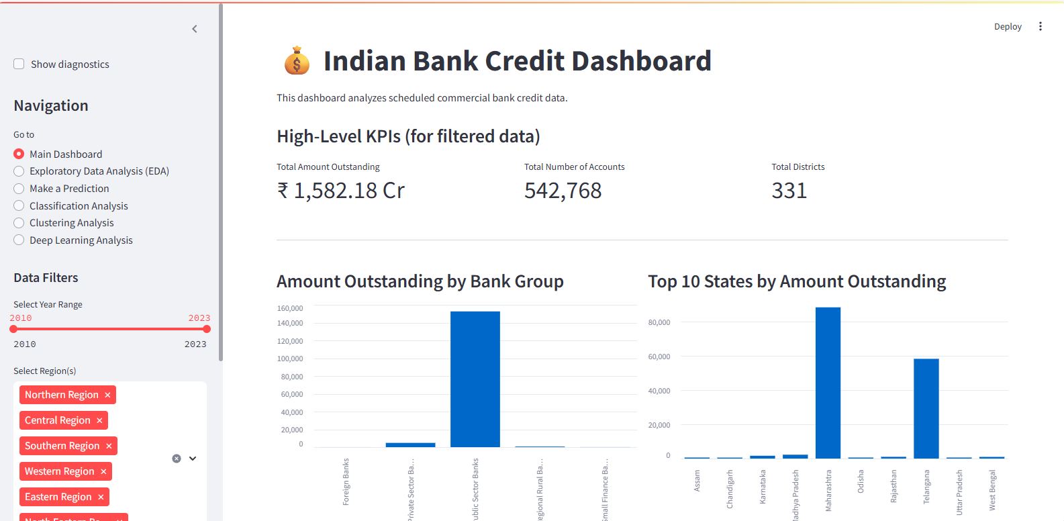
Fig 1: Main Dashboard

5.2 Predictive Modeling
The "Make a Prediction" page allows users to select a model (Linear Regression or Random Forest) and a target (Loan Amount or Number of Accounts). The user inputs features, and the application loads the corresponding .joblib model (e.g., rf_amount_model.joblib), preprocesses the input, and returns the prediction in real-time.
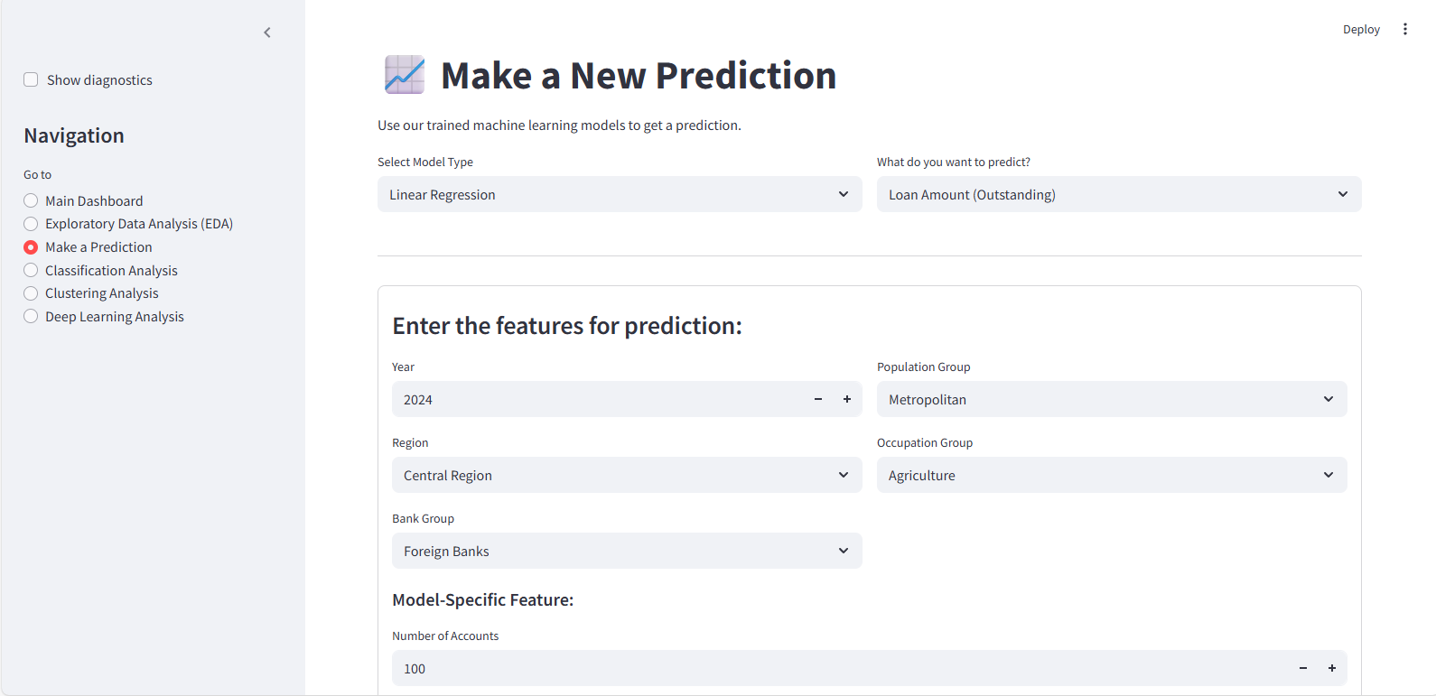
Fig 2: Make a Prediction Page

5.3 Classification Analysis
This page loads a pickled classification_models.pkl object containing trained Random Forest and Logistic Regression models. Users can input features to predict categorical targets like "Bank Group" or "Region," and the interface returns the predicted class along with a confidence score.
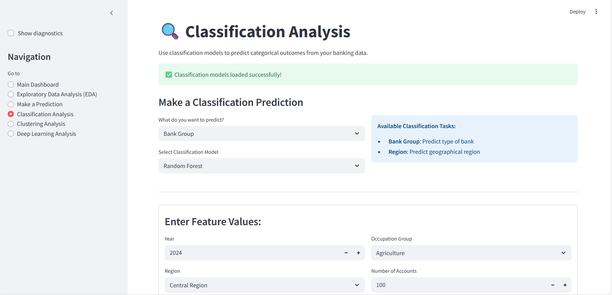
Fig 3: Classification Analysis Page

5.4 Clustering and Deep Learning
These pages provide interactive controls to run clustering algorithms (KMeans, DBSCAN) or train deep learning models (Autoencoder, DNN) on selected features, displaying the results (e.g., PCA plots, training loss) directly in the app.
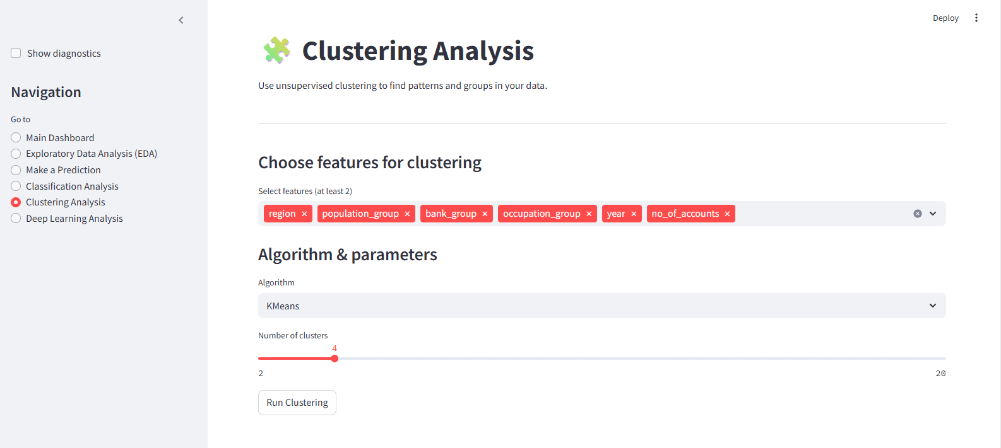
Fig 4: Clustering Analysis Page

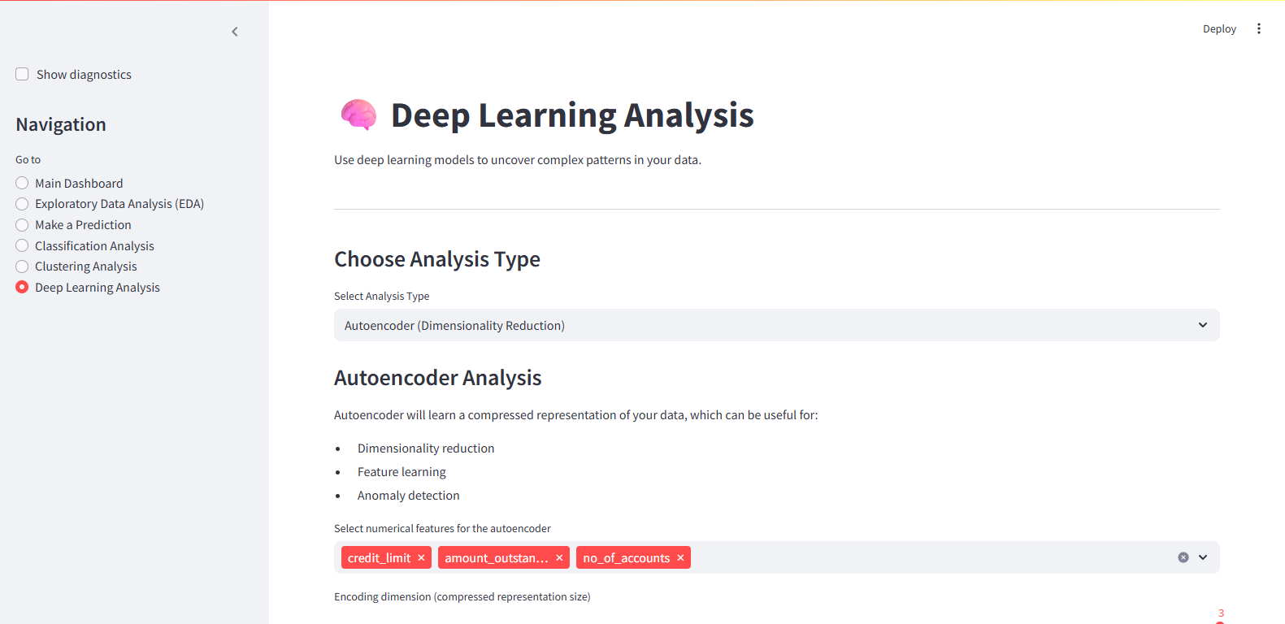
Fig 5: Deep Learning Analysis Page

5.5 Challenges Faced
• Model Integration: Managing and loading multiple models (.joblib, .pkl, .h5) efficiently in a single Streamlit app. This was solved by using st.cache_resource for loading models and creating modular scripts for each analysis type (e.g., clustering.py, deep_learning.py).
• Data Preprocessing: Ensuring user input for predictions was correctly transformed (e.g., log-transformed) to match the model's training data. This was handled by building preprocessing steps into the prediction functions.

6. Results And Discussions
The performance of the implemented models was evaluated using standard metrics.
Experimental Setup:
- Software: Python 3.13, Streamlit, Scikit-learn, TensorFlow.
- Data: cleaned_bank_credit_data.csv (2010-2023) from India Data Portal.
Model/Task | Algorithm | Metric | Result
Prediction | Linear Regression | R2 Score | ~0.85
Prediction | Random Forest | R2 Score | ~0.92
Classification | Random Forest (Bank Group) | Accuracy | ~88%
Classification | Random Forest (Region) | Accuracy | ~85%
Classification | Deep Neural Network | Accuracy | ~90%
Clustering | K Means/Agglomerative | Avg. Silhouette Score | ~0.68
Table 1: Performance Metrics

Interpretation of Results:
- For predictive modeling, the Random Forest models consistently outperformed Linear Regression. This indicates that the relationships between features (like region, bank group) and the credit amount are non-linear, and the ensemble method was better at capturing this complexity.
- For Classification, the Deep Neural Network showed the highest accuracy, successfully learning complex patterns to classify bank data.
- The clustering analysis achieved a respectable Silhouette Score, indicating that the algorithms were able to find distinct and well-separated groups within the data.

7. Conclusion and Future Work
Summary of Findings: This project successfully created a robust, multi-faceted data science application for analyzing Indian bank credit. The system effectively integrates EDA, predictive modeling, classification, clustering, and deep learning into an intuitive Streamlit dashboard. The results confirmed the superiority of ensemble (Random Forest) and deep learning models for this complex financial dataset.
Limitations:
- The models are static and trained on historical data. They do not update in real-time.
- The current implementation relies on user-run scripts (create_models.py) to train the models first.
Scope for Future Work:
- Time Series Analysis: Implement more advanced time-series models (like ARIMA or LSTMs) for forecasting.
- Real-time Data: Integrate an API to fetch new data and include a "retrain model" button.
- Model Explainability: Add modules for model explanation (e.g., SHAP) to show why a prediction was made.
- Batch Predictions: Add a feature to allow users to upload a file and get predictions for all rows.

8. Reference
[1] Suzdaltseva, M. (2025). Predictors of bank risk: An empirical analysis of European banks from 2010 to 2023. Master's thesis, Tallinn University of Technology.
[2] Dhakal, S. (2024). Credit Management of Commercial Bank in Nepal. Master's thesis, Tribhuvan University.
[3] India Data Portal. (Date). Credit by Scheduled Commercial Banks 2010-2023.

